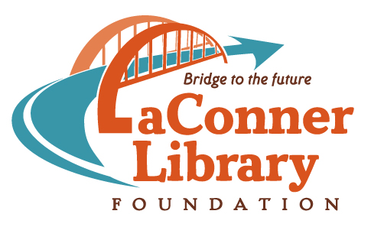

Why the library matters to me.

Please share your story!

The library is a place where people of any age can come to learn about anything. It might be information that helps them with their jobs, with school, or with their families. It’s also a place to discover and explore that wonderful place called imagination.

As part of our Bridge to the Future campaign for a new La Conner Regional Library, please tell us what the library means to you. It could be an experience at any library, at any point in your life. If you have images or video to share, please let us know.

Thank you for sharing your story!
First name |  | Last name
Email address |  | Phone number
What I do |  | (occupation, student, retired, etc.)

Here is why the library matters to me:

☐ I give permission to the La Conner Library Foundation to make or use digital images, video, audio recordings, personal stories or other reproductions of me, or of materials owned by me and to put the finished digital images, audio recordings, personal stories, or other reproductions to use without compensation in DVD productions, print publications, on the web (including YouTube), or other printed or electronic materials for the promotion of, or fundraising for, La Conner Regional Library District. I also understand that stories may be edited for space purposes and that La Conner Library Foundation reserves the right to select which stories are published online.

Mail your story: Susan Macek, Director, La Conner Library Foundation, PO Box 1025, La Conner, WA 98257
Or take it to the La Conner Regional Library

